LAB 3
Q1
.data
x byte 10h
y byte 20h
.code
MOV al,x
inc al
mov ah,y
dec ah
add ah,y
sub al,ah
mov x,al
mov bl,x
call DumpRegs

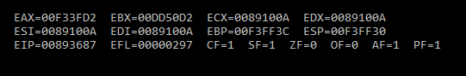
Q2
.data
val1 word 8h
val2 word 15h
val3 word 20h
.code
neg val2
mov ax,val2
add ax,7h
sub ax,val3
add ax,val1
mov ebx,eax
call DumpRegs

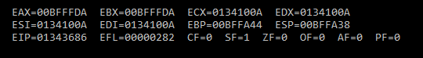
Q3

.data
len word 8h
area word ?
.code
movzx eax,len
mul ax
mov area,ax
movzx ebx,area
call DumpRegs

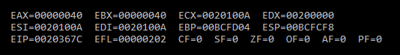

Q4
.data
len word 8h
wid word 9h
area word ?
.code
movzx eax,len
mul wid
mov area,ax
movzx ebx,area
call DumpRegs

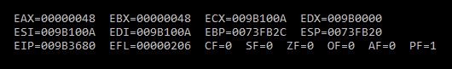

Q5
.data
h word 8h
alt word 15h
area word ?
a byte 2h
.code
movzx eax,h
mul alt
div a
mov area,ax
movzx ebx,area

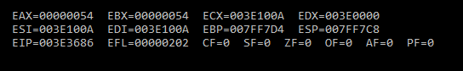

Q6
.data
val1 BYTE 10h
val2 WORD 8000h
val3 DWORD 0FFFFh
val4 WORD 7FFFh
.code
main PROC
;i
inc val2
movzx ebx,val2

;ii
sub eax,val3
;iii
movzx ecx,bx
sub cx,val4
;v
inc val4
movzx edx,val4
call DumpRegs

